[ZANG] - [Chuanjie]

Student ID: 699382953

[chuanjiezang@gmail.com](mailto:chuanjiezang@gmail.com)

1. **Entity Relation Diagram**

User: Contains user information such as UserID (PK) and username.

Role: Contains role information such as RoleID (PK) and role name.

Permission: Contains permission information such as PermissionID (PK) and permission name.

User Role Association: Used to establish the relationship between users and roles, containing UserID (FK) and RoleID (FK).

Role Permission Association: Used to establish the relationship between roles and permissions, containing RoleID (FK) and PermissionID (FK).

The connection methods are:

Between User and User Role Association: It is a one-to-many relationship, where one user can have multiple roles. The connection is between the UserID (PK) in the User table and the UserID (FK) in the User Role Association table.

Between Role and User Role Association: It is also a one-to-many relationship, where one role can be owned by multiple users. The connection is between the RoleID (PK) in the Role table and the RoleID (FK) in the User Role Association table.

Between Role and Role Permission Association: It is a one-to-many relationship, where one role can have multiple permissions. The connection is between the RoleID (PK) in the Role table and the RoleID (FK) in the Role Permission Association table.

Between Permission and Role Permission Association: It is also a one-to-many relationship, where one permission can be owned by multiple roles. The connection is between the PermissionID (PK) in the Permission table and the PermissionID (FK) in the Role Permission Association table.

I use drawio to draw.

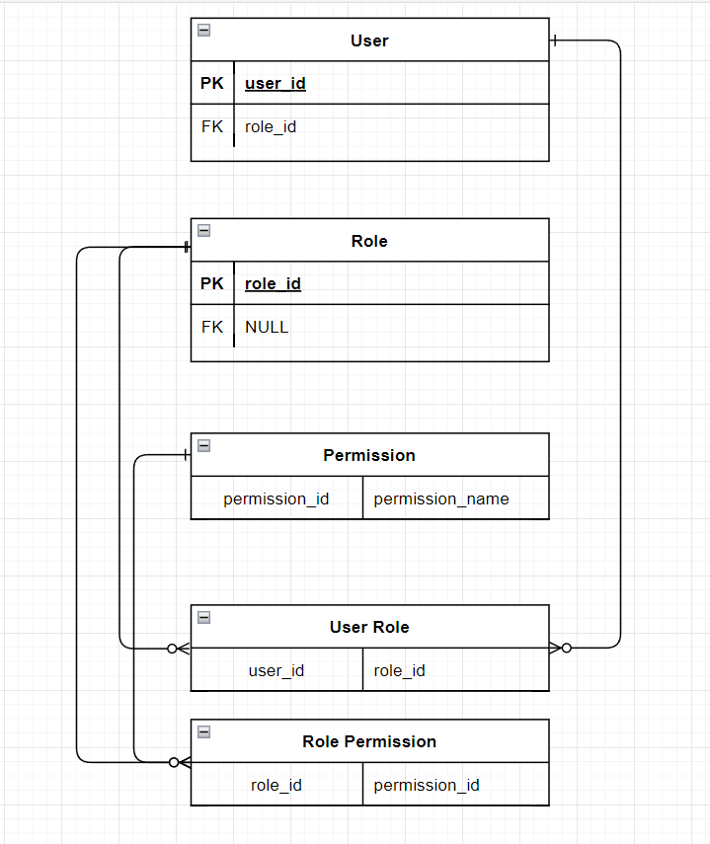

1. **Data Flow Diagram**

PermissionID (PK) in the Permission table and the PermissionID (FK) in the Role Permission Association table.

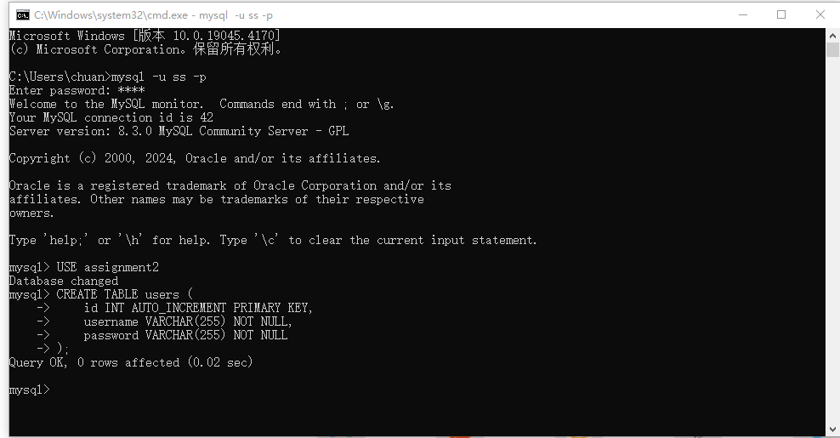

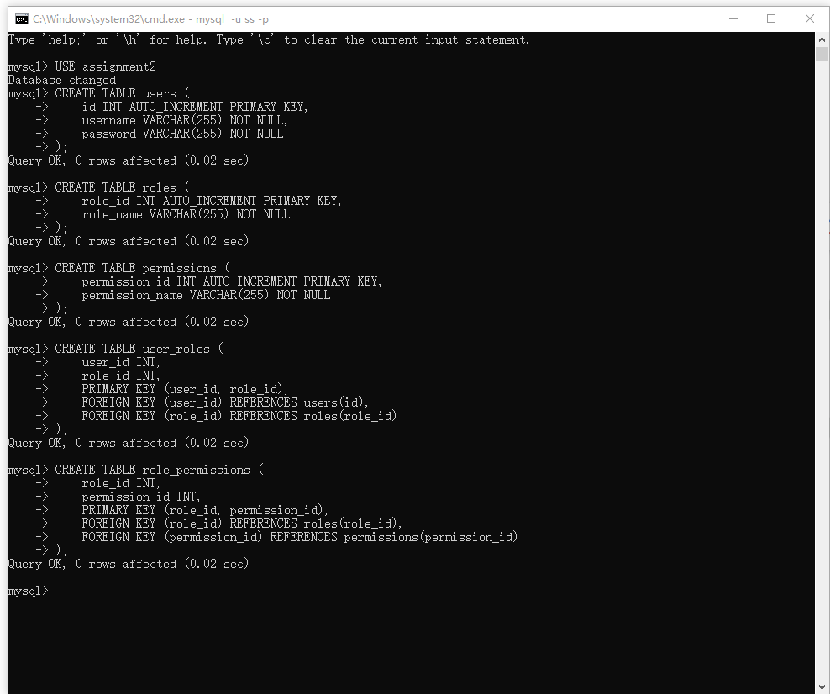

MVC:

login_system/

├── app/

│ ├── controllers/

│ │ ├── LoginController.php

│ │ └── RegisterController.php

│ ├── models/

│ │ ├── User.php

│ │ ├── Role.php

│ │

│ └── views/

│ ├── login.php

│ ├── register.php

│ └── welcome.php

├── config/

│ └── db_connect.php

├── public/

│ │ ├── login.html

│ ├── register.html

│ └── styles.css

└── setup/

└── setup_tables.php

├── ─assignment2.html

├── ─assignment2_script.js

├── ─assignment2_styles.css

├── ─init_database.php

├── ──install.php

Note that here you need to set the root directory to the "login_system"

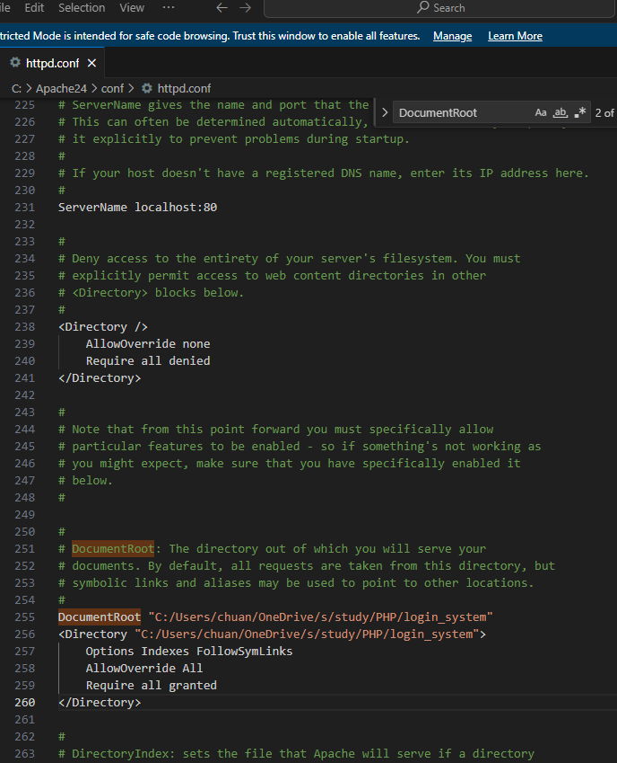

Here is how i set the MySQL,

I use database: assignment2

And create form username, password, to store.

Im using ss as mysql name, password:7147, database name:assignment2

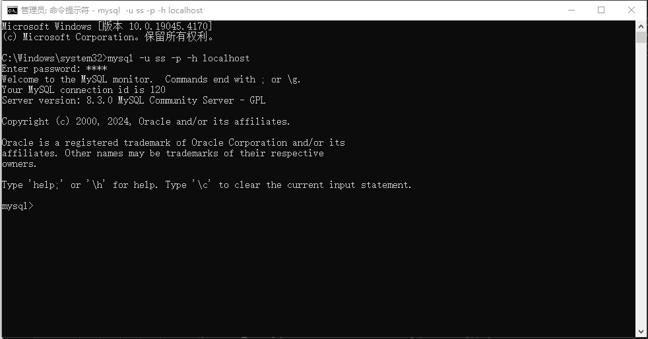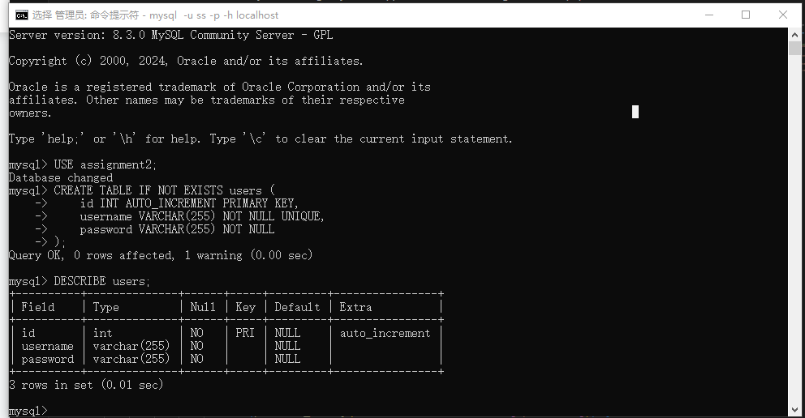

To use the program's process,

first open the initial page using localhost/assignment2.html.

Then you can login , register etc.

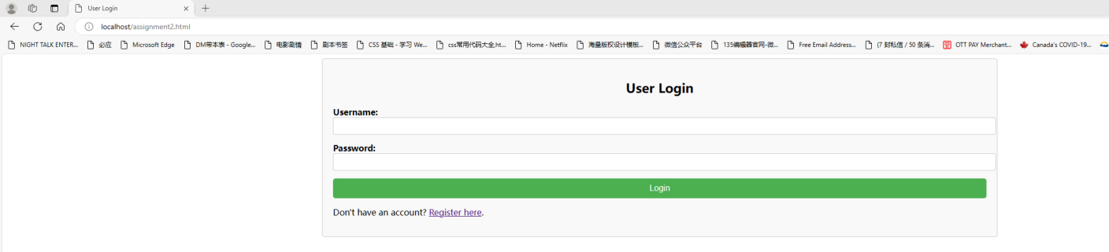

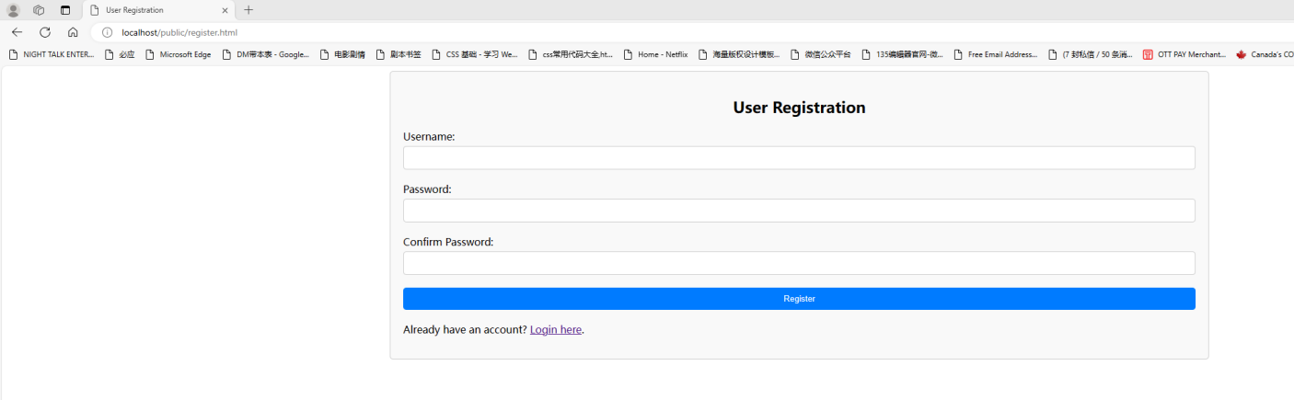

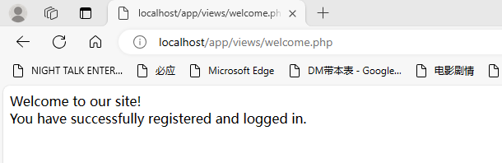

[ZANG] - [Chuanjie]

Student ID: 699382953

[chuanjiezang@gmail.com](mailto:chuanjiezang@gmail.com)